Comparisons of the performance of ML algorithms on DNA methylation data for the identification of disease-relevant biomarkers
Yogesh Aravamudhan¹, Aleksandr V. Sokolov¹, Helgi B. Schiöth^{1,2*}
¹Department of Surgical Sciences, Functional Pharmacology and Neuroscience, Uppsala University, Uppsala, Sweden.
²Laboratory of Pharmaceutical Pharmacology, Latvian Institute of Organic Synthesis, Riga, Latvia.
* Corresponding author at: Department of Surgical Sciences, Functional Pharmacology and Neuroscience, Uppsala University, BMC Box 593, Husargatan 3, 751 24, Uppsala, Sweden. Email: helgi.schioth@uu.se
Keywords:
Abstract
Background: A large amount of DNA methylation data has been collected in recent years, found in open data sources. Machine Learning (ML) is revolutionising data analysis across diverse fields, including disease diagnosis and biomarker discovery. Differential methylation analysis has traditionally relied on tools like the R package limma to detect differentially methylated CpG sites.
Methods: We analysed whole-genome DNA methylation (DNAm) data for Major Depressive Disorder (MDD), Acute Myeloid Leukaemia (AML), and Breast Cancer (BRCA). MDD data (1630 samples) were sourced from multiple Gene Expression Omnibus cohorts, while AML (255 samples) and BRCA (890 samples) were obtained from Genomic Data Commons. Preprocessing varied, with SeSAMe pipeline for AML/BRCA and comparisons of conventional vs. minimal processing for MDD. Machine learning models, including logistic regression, decision trees, random forest, SVMs, and kNN, were trained on a local CPU-based system. Feature selection via random forest informed Gene Oncology and KEGG pathway enrichment using missMethyl.
Results: We found that Random Forest classifier among other ML classifiers performed well across multiple datasets and that the feature importances yielded CpG sites that are linked to known biomarkers. These CpG sites were significantly different, from the CpG sites identified through differential methylation analysis with less than 10% CpG sites common between the two approaches. We also observed that not performing extensive preprocessing of the datasets does not affect the performance of ML classifiers There is also no significant difference between beta and m-values for methylation data representation.
Conclusion: We demonstrate that popular ML algorithms in scikit-learn (Python) can replicate and may complement limma by identifying unique CpG sites relevant to disease diagnosis. Our study highlights its suitability for integrating ML into pipelines for disease diagnosis and biomarker identification. By offering a robust alternative to traditional approaches, ML-driven analysis of DNAm data could accelerate advancements in precision medicine.
1. Introduction
Epigenetic modifications are heritable, reversible changes to gene expression that do not involve alterations to the underlying DNA sequence. Among these modifications, DNA methylation (DNAm) is one of the most well-studied mechanisms, as it plays a critical role in various cellular processes. It is the addition of a methyl group to the 5’ position of cytosine residues, primarily at CpG dinucleotide(1). Aberrant methylation patterns have been implicated in the pathogenesis of numerous diseases, most notably cancer(2–4), but also neurodegenerative disorders(5,6), and psychiatric conditions such as depression(7–9).
With the advent of high-throughput technologies such as the Illumina Infinium MethylationEPIC Bead Chip array and Whole-Genome Bisulfite Sequencing (WGBS), researchers now have access to large-scale DNAm data from a variety of tissues and disease contexts(10). Public repositories like the Gene Expression Omnibus (GEO), The Cancer Genome Atlas (TCGA), and the Genomic Data Commons (GDC) host vast amounts of DNAm data in standardised formats (e.g., IDAT, TXT, and CSV), representing both raw and processed measurements of methylation levels at hundreds of thousands of CpG sites per sample.
However, the analysis of DNAm data remains a considerable challenge due to several technical and biological factors. First, DNAm datasets are high-dimensional, often comprising around 850,000 CpG sites per sample on EPIC arrays, making computational processing and memory requirements demanding. Second, data collected across different platforms and laboratories are susceptible to batch effects, platform-specific biases, and variable preprocessing protocols, all of which can introduce confounding variation that masks true biological signals(11). Third, DNAm patterns are highly context-dependent, influenced by age, sex, ethnicity, cell type composition, environmental exposures, and disease state, necessitating careful adjustment to reduce confounding(12). Furthermore, missing data due to poor-quality probes or hybridisation failures are common and require imputation strategies, which can inadvertently introduce artefacts.
Traditional approaches to DNAm analysis rely heavily on statistical frameworks such as limma(13), minfi(14), and DESeq2(15), which are designed to detect differentially methylated positions or regions between predefined sample groups using linear modelling methods. While these tools are robust and statistically rigorous, they have several limitations. They typically make assumptions about the distributions of methylation beta values, which may not hold for all loci or sample types. Additionally, these models often apply strict statistical thresholds which are arbitrary in nature (e.g., false discovery rate-adjusted p-values), which may filter out CpG sites with potentially important biological relevance. Most critically, traditional methods treat CpG sites independently, thereby ignoring possible interactions or combinatorial methylation signatures that could provide insight into disease mechanisms or regulatory pathways.
Furthermore, the preprocessing pipeline for DNAm analysis, encompassing background correction, probe filtering (e.g., removal of cross-reactive or SNP-associated probes), and batch effect adjustment, requires expertise and subjective decision-making, leading to inconsistencies across studies. As a result, there is a possibility that traditional statistical methods may not fully capture the complex, multivariate, and nonlinear patterns inherent in DNAm data.
In recent years, machine learning (ML) has emerged as a powerful alternative for the analysis of complex biological datasets. Unlike traditional methods that rely on predefined assumptions, ML algorithms are data-driven and capable of uncovering latent patterns and high-order interactions without explicit feature engineering. ML approaches, such as random forests, support vector machines (SVMs), and regularised logistic regression, are particularly well-suited for high-dimensional, tabular data like DNAm matrices. These models can identify relevant CpG sites, learn nonlinear relationships, and classify disease states with high accuracy. Importantly, many ML methods require less preprocessing, are relatively robust to noise, and can handle missing values more gracefully than statistical models.
While deep learning methods (e.g., neural networks, autoencoders) have shown promise in DNAm analysis, their performance is highly dependent on large training datasets and computational resources, which limits their applicability in smaller laboratory/clinical settings. In contrast, conventional ML techniques strike a balance between performance, interpretability, and usability, making them accessible to researchers familiar with statistical software but not necessarily advanced programming or computational infrastructure.
Given these advantages, ML presents an opportunity to enhance biomarker discovery, improve disease classification, and uncover novel epigenetic patterns. However, comparative evaluations of ML models versus traditional statistical approaches for DNAm analysis are still limited, and standardised workflows for integrating ML into epigenomic research are lacking.
In this study, we aim to systematically evaluate the potential of machine learning in identifying disease-associated CpG sites and predicting disease states using DNAm datasets of different diseases. By implementing and benchmarking multiple ML models, including random forests, SVMs, and logistic regression, across datasets sourced from GEO, TCGA, and other repositories, we assess their performance relative to traditional statistical methods. We also examine the impact of preprocessing choices, feature selection strategies, and confounding variable adjustment on model performance. Our findings aim to contribute to the growing field of computational epigenetics, suggesting a practical pathway for incorporating ML into DNAm analysis workflows and accelerating biomarker discovery in complex diseases.

2. Materials and Methodology
2.1 Datasets

Whole genome DNAm data was acquired for 3 different diseases for this study, namely Major Depressive Disorder, Acute Myeloid Leukaemia, and Breast Cancer. We used a multi-cohort dataset of Major Depressive Disorder from a previous study(16), which included Max Planck Institute of Psychiatry cohort 1 (GSE125105_MPIP)(17), Max Planck Institute of Psychiatry cohort 2 (GSE74414_MPIP2)(18), Grady Trauma Project cohort (GSE72680_GRADY)(19), Royal Devon and Exeter (RDE) cohort (GSE113725_RDE)(20), Molecular Biomarkers of Antidepressant Response cohort (GSE198904_DHRC)(21), and Observational clinical study cohort NCT02489305 (GSE198904_OBS)(21). These were obtained from Gene Expression Omnibus. The combined dataset with all the cohorts contained a total of 1630 samples.

The TARGET-AML (Acute Myeloid Leukaemia) dataset(22) was used to obtain DNAm data of 255 samples including primary cancer, recurrent cancer, and control. The Breast Cancer data was from The Cancer Genome Atlas’ TCGA_BRCA project(23). This contained a total of 890 samples. Both these datasets were obtained from the Genomic Data Commons portal using the TCGAbiolinks(24) package in R programming language.

The diseases (and datasets) were chosen based on the sample size of the cohorts (large, medium, small) and to compare completely different types of diseases such as depression and cancer.

2.2 DNA methylation data preprocessing

The DNAm data was not pre-processed with the usual differential methylation analysis pipeline for ML classification training. The TARGET-AML and TCGA-BRCA datasets were already processed with SeSAMe(25) pipeline, so we simply saved them with GDCprepare from the TCGAbiolinks package and later dropped the empty values. For the multi-cohort depression dataset, we compared the performance of a conventionally pre-processed and a minimally pre-processed dataset. The conventional process was using the minfi R package, followed by background correction, quantile normalisation, and correction for type I and type II probe bias, using the Beta Mixture Quantile Dilation method, removal of sex chromosome probes, SNP-related probes, and cross-reactive probes. Participant and CpG site filtering was based on detection p-values, and the bead batch effect correction was performed. This was compared with just p-values based CpG site filtering and sex chromosome probe removal.

We also compared the m-value and beta-value on the performance of classifiers on all three datasets. DNAm intensity could be represented as either beta-values or as M-values.

2.3 ML Classifiers

The Python module scikit-learn was used as a source for ML classifiers. The models included “ridge” logistic regression (“L2” regularization), decision trees, random forest, support vector machines (SVMs) with radial basis function (RBF) kernels, and k-nearest neighbours. The naive Bayes algorithm was used as a benchmark. These classifiers were specifically chosen with the size, time to train, and complexity of setting up as factors for consideration.

2.4 Training

Model training and all other computational tasks were performed at the local computer: Intel Xeon® W-2245 CPU @ 3.90GHz × 16, Memory - 62.5 GB. All classifiers were trained and tested iteratively for 20 iterations and the evaluation metrics were averaged for the AML and BRCA datasets, with an 80/20 train/test random split for every iteration. For the depression multi-cohort dataset, various group-based splitting methods (cross-validation) were compared. Training time ranged from 30 to 90 minutes for all iterations, depending on the dataset.

2.5 Differential Methylation Analysis

The limma package on the R environment was used to perform differential methylation analysis on the same datasets (including preprocessing steps) that were used for ML classification. A linear model and empirical Bayes moderation were used for the same.

2.6 Feature Selection and Enrichment Analysis
Feature selection was based on the Random Forest feature importances function. The random forest classifier was used to select the most relevant features. The top 1000 features from the random forest feature importance and the top 1000 differentially methylated sites from limma were both used for enrichment analysis of Gene Ontology (GO) Kyoto Encyclopedia of Genes and Genomes (KEGG) and the pathways obtained from both were compared. This was done with the missMethyl(26) package on R.

2.7 Train-Test Splitting and Hyperparameter Tuning
We used an 80:20 train-test split, repeated over 20 iterations, for robust benchmarking. For the AML and BRCA datasets, a stratified split ensured a balanced class distribution. In the MDD dataset, cohort-based grouping was considered, and multiple splitting strategies from scikit-learn were evaluated. Classifiers were primarily trained with default parameters, as hyperparameter tuning did not yield significant performance improvements. The selected algorithms are well-optimized for their default settings, making additional tuning unnecessary for this study.
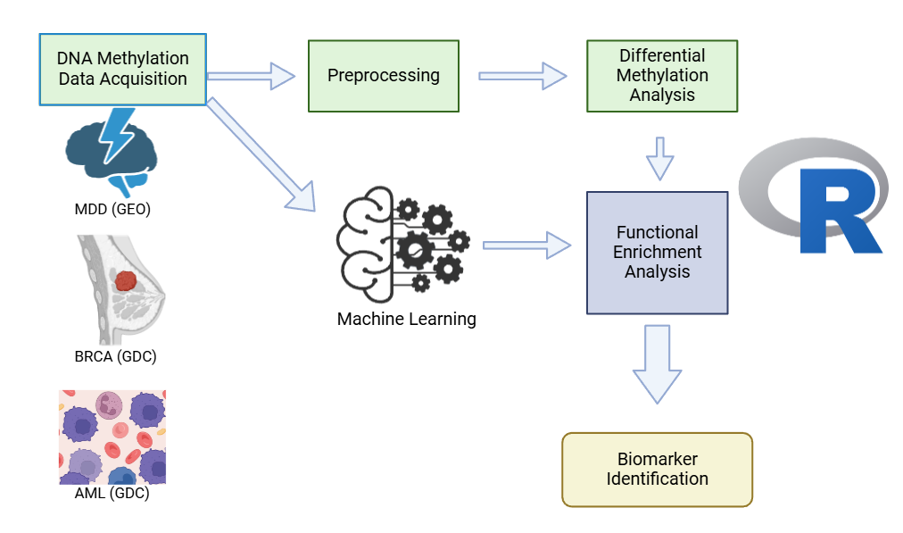
Figure 1. This figure shows the workflow of the study. We start with acquiring and curating multiple disease datasets, including different population cohorts. After acquiring the data, we preprocess it to standardise the data based on quality controls for the differential methylation analysis pipeline. Differential methylation analysis and Machine Learning based classification are performed simultaneously. We perform Functional enrichment analysis to identify significant biological pathways based on features identified by both ML and differential methylation analysis. We try to identify biomarkers based on both these approaches and compare the results.

3. Results
3.1 Comparison of algorithm performances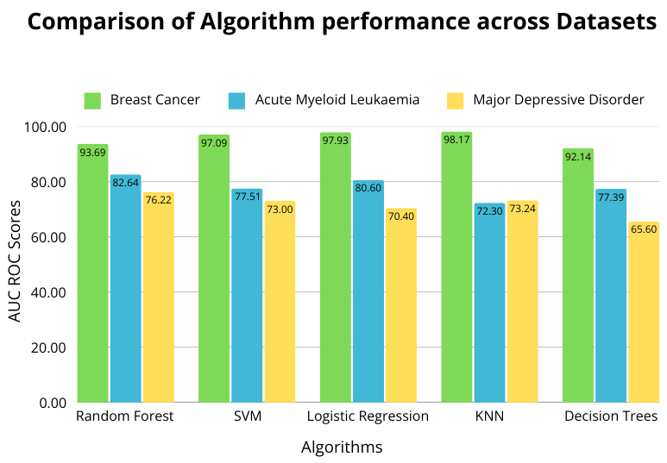
Figure 2. The bar chart compares the AUC-ROC scores of five machine learning algorithms across three datasets: Breast Cancer (BRCA), Acute Myeloid Leukaemia (AML), and Major Depressive Disorder (MDD). Random Forest and KNN achieved the highest performance in the BC dataset (93.69 and 98.17, respectively), while SVM and Logistic Regression also performed well. Performance was lower in AML and MDD, with Random Forest and SVM still ranking highest. Decision Trees consistently performed the worst, especially in MDD (65.60). Overall, Random Forest had a strong performance across all datasets, making it the most robust classifier in this study.

3.2 Beta-values vs M-values
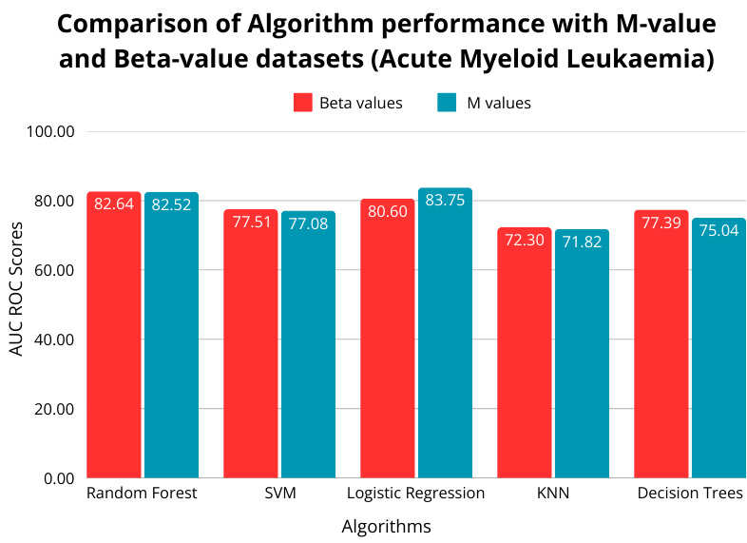
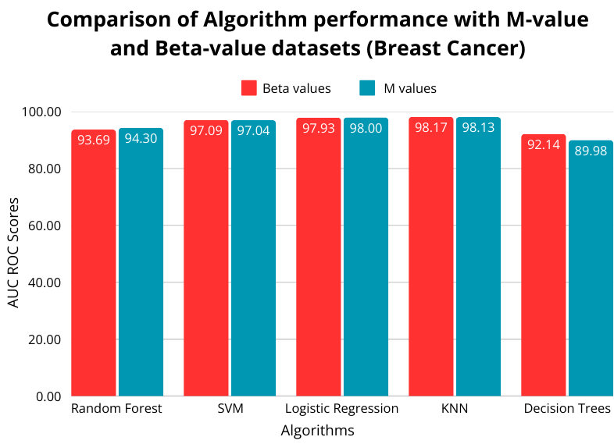
Figure 3&4. From these graphs that compared the AUC ROC scores of the classifiers between the beta-value dataset and the m-value dataset for both AML and BRCA, we can see that the choice of representation of DNAm intensity did not have any significant impact on the model’s performance. With the MDD dataset,

3.3 Functional Enrichment Analysis
We obtained the top 1000 important features for the random forest classifier because it was the better performing algorithm. We also performed differential methylation analysis using limma to get the top 1000 differentially methylated CpG sites. Using these two lists, we performed gene ontology enrichment analysis and KEGG pathway analysis and the results are attached in the supplementary materials.

We found that the overlap of CpG sites identified by Random Forest and Differential Methylation was very minimal. In the BRCA dataset, 98 out of 1000 features were present in both lists and in the MDD dataset only 13 features were common out of the top 1000 random forest features and differentially methylated sites.

Both the CpG lists obtained from ML and Differential methylation analysis pointed towards GO and KEGG pathways that have been identified as biomarkers for the disease. The different methods identified different pathways which had no noticeable overlap between each other.

4. Discussion
This study demonstrates that the Random Forest classifier consistently achieved high performance across all datasets, positioning it as the most robust ML model for DNAm-based classification tasks. This consistency highlights Random Forest's utility in epigenetic research, particularly in contexts where predictive accuracy and model interpretability are essential. Importantly, the choice between beta-value and m-value representations of DNAm intensity did not significantly influence model performance although a difference has been noted for other non ML approaches(27). This finding suggests that the choice of representation, while critical for some analyses, may be flexible in machine learning pipelines without compromising classification outcomes.
A key component of this study involved comparing feature sets derived from Random Forest’s top 1000 ranked features with those identified through limma-based differential methylation analysis. Both feature sets were subjected to GO and KEGG pathway enrichment analyses to evaluate their biological relevance. Interestingly, there was minimal overlap between the CpG sites identified by these two approaches, particularly in the MDD dataset. This divergence highlights a critical insight: machine learning and traditional statistical methods capture distinct, and potentially complementary, aspects of methylation patterns.
One of the most compelling findings of this study is that pathway enrichment analysis based on Random Forest-selected features uncovered biologically meaningful pathways that have been previously implicated in disease. Despite the lack of overlap with limma-derived sites, these pathways aligned with known biomarkers and biological mechanisms relevant to the diseases under investigation. This indicates that ML-based feature selection can uncover alternative biological insights, emphasising the potential of data-driven, model-informed selection in augmenting traditional hypothesis-driven analyses.
Some of the pathways identified by random forest classifier which were ignored by differential methylation analysis are natural killer cell cytotoxicity (28,29), ECM receptor interaction(30,31), nuclear steroid receptor activity(32,33), autocrine signalling(34), etc for breast cancer; platelet activation(35,36), dilated cardiomyopathy(37,38) for depression, among other relations which are included in the supplementary data.
This indicates that ML-based feature selection can uncover alternative biological insights, emphasising the potential of data-driven, model-informed selection in augmenting traditional hypothesis-driven analyses. This divergence in pathway identification underscores fundamental methodological differences. Statistical approaches like limma are designed to detect CpG sites with statistically significant differential methylation between cases and controls. In contrast, Random Forest selects features based on their importance in improving classification performance. As such, Random Forest may identify CpG sites that are not the most differentially methylated but contribute meaningfully to distinguishing disease states, highlighting patterns that are potentially overlooked by p-value-centric methods.
Moreover, this study emphasises the practical advantages of using ensemble ML models like Random Forest in bioinformatics pipelines. Despite the growing popularity of deep learning (DL) in genomics, DL models often require extensive computational resources, large datasets, and fine-tuning expertise. In contrast, DNAm data are typically structured and tabular in format, making them well-suited to traditional ML methods. The strong performance of Random Forest on such data indicates that simpler, more interpretable, and computationally efficient models can achieve comparable results for tasks like disease classification and biomarker discovery.
This has important implications for the design of future bioinformatics workflows. Instead of defaulting to complex DL architectures, researchers and clinicians may opt for scalable ML approaches that are easier to deploy and maintain, particularly in resource-limited settings. Furthermore, such pipelines are more accessible to non-specialists, fostering broader adoption of DNAm-based biomarkers in clinical practice.
Finally, the complementary nature of ML and traditional statistical approaches suggests a promising direction for integrative biomarker discovery. Rather than viewing ML and statistical methods as competing paradigms, they should be seen as synergistic tools. While statistical tests provide robust assessments of differential methylation, ML models offer a performance-driven lens through which to assess the predictive relevance of methylation patterns. By integrating both approaches, researchers can achieve a more holistic understanding of DNAm alterations, yielding richer insights into disease mechanisms and improving the identification of reliable, functionally relevant biomarkers for diagnostics and targeted therapeutics.
4.1 Limitations and Future Research
Despite the promising findings, this study has several limitations. First, the analysis was limited to a specific number of datasets and disease contexts, which may affect the generalizability of the results across other biological conditions or tissue types. Future studies should evaluate whether the observed patterns hold across a broader range of diseases and population cohorts. Second, while Random Forest proved to be a powerful tool for classification and feature selection, it needs more transparency in its decision-making process compared to more interpretable models or statistical approaches. Additional research should explore hybrid methods that maintain high accuracy while enhancing interpretability. Third, pathway enrichment analyses were based on existing gene annotations, which are continually evolving; thus, some biologically relevant signals may remain undetected due to annotation limitations.
Future work should also examine how ML-derived features behave in more constrained settings and whether they can predict disease onset or progression over time. Furthermore, validating the identified CpG sites and pathways in independent experimental studies will be essential to confirm their biological relevance. Integrating DNAm data with other omics layers, such as transcriptomics or proteomics, may provide deeper insights into the regulatory landscape and facilitate the discovery of multi-layered biomarkers for complex diseases.
5. Conflict of Interest

6. Author Contributions

7. Funding

8. Acknowledgements

9. AI Usage
We used ChatGPT-4 for rephrasing and rewriting the paragraphs for readability. We verified and re-read the paragraphs and take full accountability for the content.

10. References
1. Chiam K, Tilley WD, Butler LM, Bianco-Miotto T. The dynamic and static modification of the epigenome by hormones: A role in the developmental origin of hormone related cancers. Biochim Biophys Acta BBA - Rev Cancer. 2009 Apr;1795(2):104–9.
2. Kanwal R, Gupta S. Epigenetic modifications in cancer. Clin Genet. 2012 Apr;81(4):303–11.
3. Kulis M, Esteller M. DNA Methylation and Cancer. In: Advances in Genetics [Internet]. Elsevier; 2010 [cited 2025 May 5]. p. 27–56. Available from: https://linkinghub.elsevier.com/retrieve/pii/B9780123808660600022
4. Papanicolau-Sengos A, Aldape K. DNA Methylation Profiling: An Emerging Paradigm for Cancer Diagnosis. Annu Rev Pathol Mech Dis. 2022 Jan 24;17(1):295–321.
5. De Jager PL, Srivastava G, Lunnon K, Burgess J, Schalkwyk LC, Yu L, et al. Alzheimer’s disease: early alterations in brain DNA methylation at ANK1, BIN1, RHBDF2 and other loci. Nat Neurosci. 2014 Sep;17(9):1156–63.
6. Kaur G, Rathod SSS, Ghoneim MM, Alshehri S, Ahmad J, Mishra A, et al. DNA Methylation: A Promising Approach in Management of Alzheimer’s Disease and Other Neurodegenerative Disorders. Biology. 2022 Jan 7;11(1):90.
7. Li M, D’Arcy C, Li X, Zhang T, Joober R, Meng X. What do DNA methylation studies tell us about depression? A systematic review. Transl Psychiatry. 2019 Feb 4;9(1):68.
8. Nakamura Y, Nakatochi M, Kunimoto S, Okada T, Aleksic B, Toyama M, et al. Methylation analysis for postpartum depression: a case control study. BMC Psychiatry. 2019 Dec;19(1):190.
9. Li QS, Morrison RL, Turecki G, Drevets WC. Meta-analysis of epigenome-wide association studies of major depressive disorder. Sci Rep. 2022 Nov 1;12(1):18361.
10. Rauluseviciute I, Drabløs F, Rye MB. DNA methylation data by sequencing: experimental approaches and recommendations for tools and pipelines for data analysis. Clin Epigenetics. 2019 Dec;11(1):193.
11. Leek JT, Scharpf RB, Bravo HC, Simcha D, Langmead B, Johnson WE, et al. Tackling the widespread and critical impact of batch effects in high-throughput data. Nat Rev Genet. 2010 Oct;11(10):733–9.
12. Jaffe AE, Irizarry RA. Accounting for cellular heterogeneity is critical in epigenome-wide association studies. Genome Biol. 2014 Feb 4;15(2):R31.
13. Ritchie ME, Phipson B, Wu D, Hu Y, Law CW, Shi W, et al. limma powers differential expression analyses for RNA-sequencing and microarray studies. Nucleic Acids Res. 2015 Apr 20;43(7):e47–e47.
14. Fortin JP, Triche TJ, Hansen KD. Preprocessing, normalization and integration of the Illumina HumanMethylationEPIC array with minfi. Hancock J, editor. Bioinformatics. 2017 Feb 15;33(4):558–60.
15. Love MI, Huber W, Anders S. Moderated estimation of fold change and dispersion for RNA-seq data with DESeq2. Genome Biol. 2014 Dec 5;15(12):550.
16. Sokolov AV, Schiöth HB. Decoding depression: a comprehensive multi-cohort exploration of blood DNA methylation using machine learning and deep learning approaches. Transl Psychiatry. 2024 Jul 15;14(1):287.
17. Arloth J, Binder E. Epigenome analysis of depressed and control subjects [Internet]. Available from: https://www.ncbi.nlm.nih.gov/geo/query/acc.cgi?acc=GSE125105
18. Arloth J, Binder E. Dexamethasone-stimulated DNA methylation of the epigenetic clock CpGs in peripheral blood [Internet]. Available from: https://www.ncbi.nlm.nih.gov/geo/query/acc.cgi?acc=GSE74414
19. Ressler K, Smith A, Binder E, Kilaru V. DNA Methylation of African Americans from the Grady Trauma Project [Internet]. Available from: https://www.ncbi.nlm.nih.gov/geo/query/acc.cgi?acc=GSE72680
20. Crawford B, Craig Z, Mansell G. DNA methylation and inflammation marker profiles associated with a history of depression [Internet]. Available from: https://www.ncbi.nlm.nih.gov/geo/query/acc.cgi?acc=GSE113725
21. Li Q. Meta-analysis of Epigenome Wide Association Studies of Major Depressive Disorder [Internet]. Available from: https://www.ncbi.nlm.nih.gov/geo/query/acc.cgi?acc=GSE198904
22. GDC Data Portal Acute Myeloid Leukemia [Internet]. Available from: https://portal.gdc.cancer.gov/projects/TARGET-AML
23. The Cancer Genome Atlas - Breast Cancer [Internet]. Available from: https://portal.gdc.cancer.gov/projects/TCGA-BRCA
24. Colaprico A, Silva TC, Olsen C, Garofano L, Cava C, Garolini D, et al. TCGAbiolinks: an R/Bioconductor package for integrative analysis of TCGA data. Nucleic Acids Res. 2016 May 5;44(8):e71–e71.
25. Zhou W, Triche TJ, Laird PW, Shen H. SeSAMe: reducing artifactual detection of DNA methylation by Infinium BeadChips in genomic deletions. Nucleic Acids Res [Internet]. 2018 Jul 31 [cited 2025 May 19]; Available from: https://academic.oup.com/nar/advance-article/doi/10.1093/nar/gky691/5061974
26. Phipson B, Maksimovic J, Oshlack A. missMethyl: an R package for analyzing data from Illumina’s HumanMethylation450 platform. Bioinformatics. 2016 Jan 15;32(2):286–8.
27. Du P, Zhang X, Huang CC, Jafari N, Kibbe WA, Hou L, et al. Comparison of Beta-value and M-value methods for quantifying methylation levels by microarray analysis. BMC Bioinformatics. 2010 Dec;11(1):587.
28. N’da Marcelin H, Dasse RS, Yeboah RO, Tariam AD, Kagambega AGZ, Oseni AM, et al. Circulating natural killer cells and their association with breast cancer and its clinico-pathological characteristics. ecancermedicalscience [Internet]. 2023 Jul 3 [cited 2025 May 19];17. Available from: https://ecancer.org/en/journal/article/1567-circulating-natural-killer-cells-and-their-association-with-breast-cancer-and-its-clinico-pathological-characteristics
29. Cooley S, Burns LJ, Repka T, Miller JS. Natural killer cell cytotoxicity of breast cancer targets is enhanced by two distinct mechanisms of antibody-dependent cellular cytotoxicity against LFA-3 and HER2/neu. Exp Hematol. 1999 Oct;27(10):1533–41.
30. Bao Y, Wang L, Shi L, Yun F, Liu X, Chen Y, et al. Transcriptome profiling revealed multiple genes and ECM-receptor interaction pathways that may be associated with breast cancer. Cell Mol Biol Lett. 2019 Dec;24(1):38.
31. Jena MK, Janjanam J. Role of extracellular matrix in breast cancer development: a brief update. F1000Research. 2018 Jun 12;7:274.
32. Kumar S, Freelander A, Lim E. Type 1 Nuclear Receptor Activity in Breast Cancer: Translating Preclinical Insights to the Clinic. Cancers. 2021 Oct 3;13(19):4972.
33. Kowalczyk W, Waliszczak G, Jach R, Dulińska-Litewka J. Steroid Receptors in Breast Cancer: Understanding of Molecular Function as a Basis for Effective Therapy Development. Cancers. 2021 Sep 24;13(19):4779.
34. Schlange T, Matsuda Y, Lienhard S, Huber A, Hynes NE. Autocrine WNT signaling contributes to breast cancer cell proliferation via the canonical WNT pathway and EGFR transactivation. Breast Cancer Res BCR. 2007;9(5):R63.
35. Williams MS. Platelets and depression in cardiovascular disease: A brief review of the current literature. World J Psychiatry. 2012 Dec 22;2(6):114–23.
36. Morel-Kopp MC, McLean L, Chen Q, Tofler GH, Tennant C, Maddison V, et al. The association of depression with platelet activation: evidence for a treatment effect. J Thromb Haemost JTH. 2009 Apr;7(4):573–81.
37. Guan S, Fang X, Hu X. Factors influencing the anxiety and depression of patients with dilated cardiomyopathy. Int J Clin Exp Med. 2014;7(12):5691–5.
38. Faris R, Purcell H, Henein MY, Coats AJS. Clinical depression is common and significantly associated with reduced survival in patients with non-ischaemic heart failure. Eur J Heart Fail. 2002 Aug;4(4):541–51.

11. Supplementary Material

12. Data Availability Statement

